# PLANTING A CHURCH IN THE SLUM

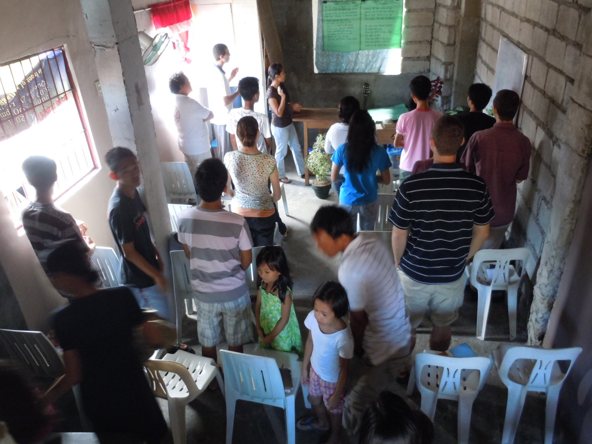

* Need
* Vision
* Plan
* Budget
* Accountability

3 planters

2 years

1 sustainable church

The Advantage of Churches in the Slums

**SLUMS THE MAJORITY – MOST RECEPTIVE TO GOSPEL**

“The United Nations’ prediction that **most of the world will be living in the cities** has finally come true. This is the result of the vast migration of poor looking for jobs, from the provinces to the cities.

“Most of these migrants end up living in the **slums**. Urban poor thus is the **new mission frontier** today and perhaps will be for the next several generations.

“The urban poor are also the most **open to the gospel**. And yet, there are very few today who are focusing on reaching this people group. There are urban missions but not urban poor mission. This slum population is growing at explosive rate but remains a neglected mission field.”

- Atty. Dr. Raineer Chu. Dissertation. 2011.

Historical Evidence

In Manila, at the beginning of the 20th century, evangelism targeted the elite. But when the *Jesus is Lord* (JIL) movement began to minister directly to the masses in the 1980’s, church growth exploded.



It stands to reason, then, to go where Manila’s masses are: in the slums.

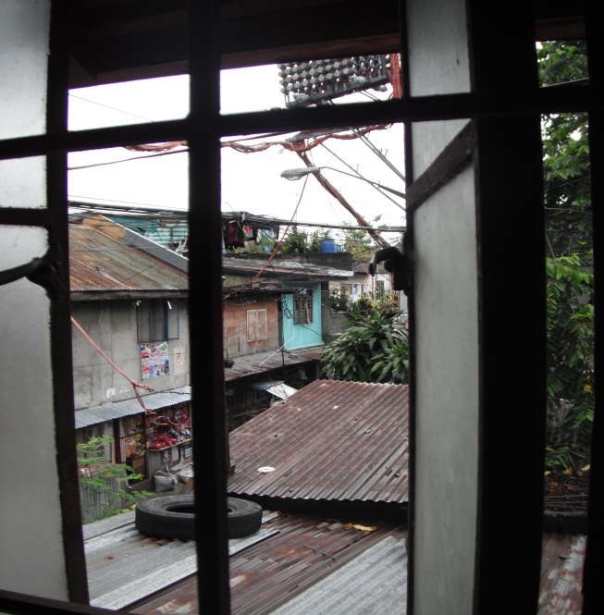

“New churches of 100 members are **16 times more effective** in winning new converts to Christ than mega churches.”

– (Schwarz in *Natural Church Development* (1996) - Surveyed over 1,000 churches from 32 countries and six continents.)

**Effective.**

“The single **most effective** evangelistic methodology under heaven is **planting new churches**.” – (Wagner (1980), quoted in Chu.)

“In view of recent global trends on urbanization, we may also add that the **most effective evangelism** is **planting new churches in the slums.**” – (Chu. Dissertation, 2011.)

“Today, already more than **40 percent** of the people of Metro Manila are **living in slums**.

The rate of urban migration is thirty percent which means that roughly **every three years the cities will double**.”

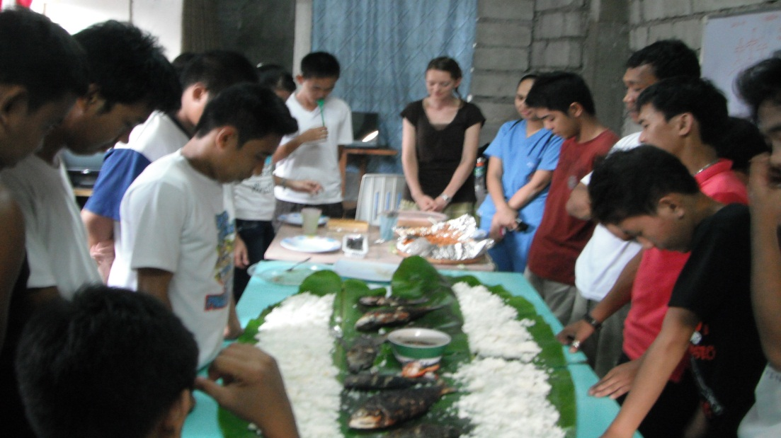

Theology of INCARNATION

Go to the people

Live among them

Love them

Learn from them

Begin with what they know

Build on what they have

"**Living among the poor** is the only possible way to plant the Christian faith among them." (Grigg. *Companion*. 20.)

"Jesus' effectiveness in evangelism was partly because of his dependence on the poor" (Grigg. *Cry.* 136)

FROM CONVERSION TO DISCIPLESHIP

"Beside **assurance and acceptance**, a growing Christian has four basic needs. He needs **protection, fellowship, food, and training**" (Eims. p63).

PEOPLE FIRST, BUILDING NEXT

Basically, it’s **people** (with good ideas & determination **gathering,** and **praying** together for what they want to see the **Holy Spirit** doing in their midst) that **catalyze the development of a new church**, not the **building** nor strategizing over location, money, and advertising. “If you build it they will come” doesn’t work in this situation. (Olson. *Organic Church Planting.*)

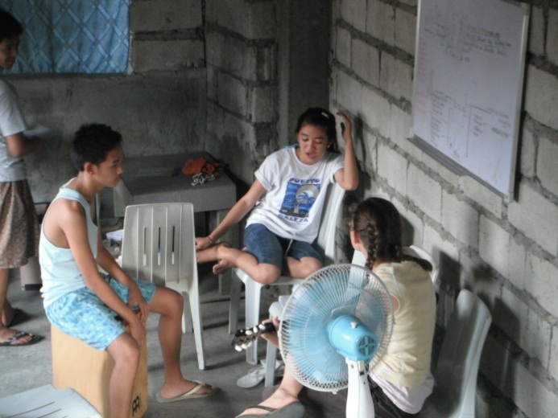

Church Planting Process

**SUCCESSFUL STRATEGIES *from* MMP *in the* SLUMS *of* MANILA:**

1. **Train** a team of 3 church planters,

one of whom will stay as pastor after 2 years

1. **Enter** community,

start knocking on doors, asking: “Might you be interested in hosting a Bible study in your home, being part of our church, and/or learning more about Jesus?”

1. **12%** (of those living in urban poor metro Manila) will say “Yes.”

Follow up, discipling responsive community members

(as discussed on next page)



*Diagram:* Becker, Carpenter, and Williams (2011). **Section Five**: Prayerful Planning.  [The New Dynamic Church planting Handbook](http://www.ocieurope.org/LinkClick.aspx?fileticket=QBToCyUH8k8=&tabid=643&mid=1477) (E-book). 187-266.

Justice for the POOR

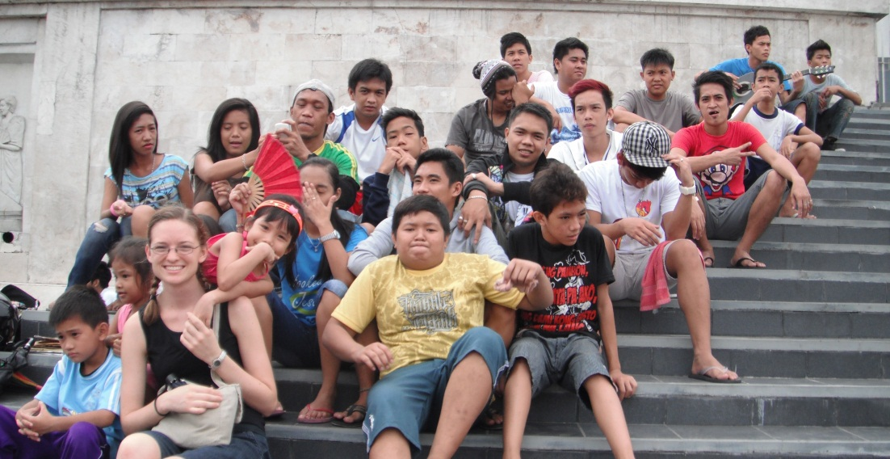

DISCIPLESHIP

"Disciple-making is God's love being poured out through one life into another, until the second life catches that love." (Grigg. *Companion.* 70.)

A **disciple** of Christ follows the **disciplines** of Christ:

* Prayer
* Humility
* Meekness
* Peacemaking

JESUS DISCIPLED BY ASSOCIATION

Nothing formal about it.

He stayed with them.

They learned his ways by just being with Jesus and seeing how he reacted, what he purposed, what he valued.

"Knowledge was gained by association before it was understood by explanation."

(Coleman, R. E. *The Master Plan of Evangelism*. )

"How do we know the way?"

"**I am** the way, the truth, and the life." [Just by knowing me, you know the way.]

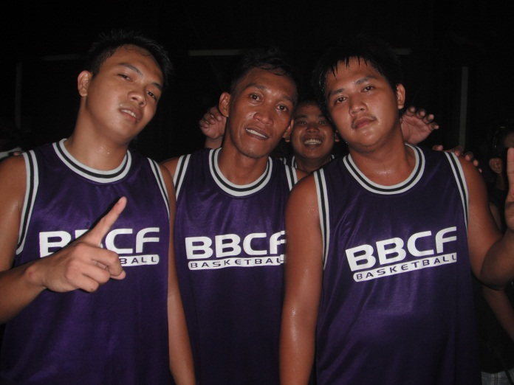

Discipleship Process

**FOUR SEASONS OF GROWTH – *for* PERSONAL DISCIPLESHIP**

The following environments ought to be created by the facilitator:

* **Security** season:
  + Fellowship; God’s forgiveness, love, and faithfulness.
* **Commitment** season:
  + Commitment to:

(1) the Lord,

(2) the church,

(3) ministry;

* + “Turning to the Word of God for practical instruction.”
* **Quality** season:
  + Discipler brings new believer into tight kinship – exposing them to his/her own intimate family life.
* **Gifts and calling** season:
  + New believer (now mature) is “deployed in a place of ministry where his or her gifts will be fully uti­lized.”

*These* principles can also be applied to the growth of a church…

Grigg, V. (2005). Group Structures for Squatter Churches. In *Cry of the Urban Poor.* GA, USA: Authentic Media.



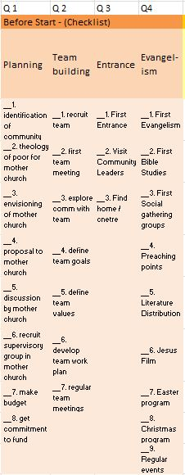

Overview:

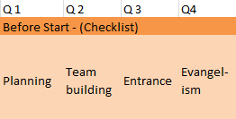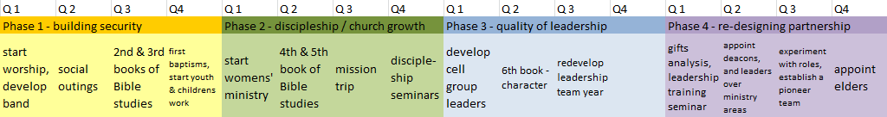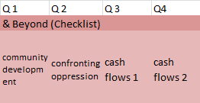

*Meeting places for initial church plant:

"Flexible thinking and multiple locations

will free you to grow at God's pace."

Why new church plants should choose temporary locations: (Moore, 2002. 115.)

1. Flexibility
2. Eliminates your major capital outlay
   1. “Saddling young churches with expensive real estate can unintentionally leverage the church plant against growth.”
3. Reduces the distraction of finding the *ultimate building*
4. Keeps expectations in check
   1. Imagine you're on a camping trip: when you know your location is temporary, you accept 'roughing it.'
5. Easy entry into ministry
   1. Things like folding chairs at the end of a service in a temporary location can give even first-timers something to do to feel that they're a useful and needed part of the community.

Planning for Entrance

Before entering phase 1, it’s essential to spend much time in prayer, deciphering & agreeing on goals and strategies in 4 major areas:

1. Planning:
   1. **Select a community** – best if it’s a **NEW SLUM**, so that the church becomes a part of the identity of the community from the beginning
   2. **Mother church** – needs to be deeply involved in the visioning & planning, so that the mother church takes ‘ownership’ of the project, producing in them a commitment to continued support. (In the experience of MMP, loss of interest by the mother church is a top reason new church plants fail.)
2. Team Building:
   1. Identify a core team
   2. Explore prospective communities together
   3. Define goals & commitment to regular meetings
3. Entrance:
   1. Inform & involve community leaders
   2. Identify possible *meeting places\**
4. Evangelism:
   1. Initiate Bible studies, social gatherings, and public events

Overview:



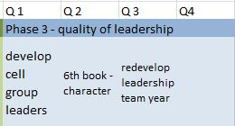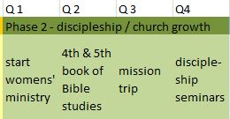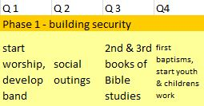

Phase 1: Security

In order to build a Christian community, interested members first need to feel secure with each other.

1. Worship:
   1. Begin worshipping together from week 1
   2. Recruit people for jobs, (ie. band, ushers… )
2. Social Outings:
   1. Create a sense of belonging together socially
3. 2nd & 3rd Bible Studies:
   1. Investigate the basics of the faith
4. Baptisms; Youth & Children Ministries

Phase 2: Discipleship / Church Growth

1. Women’s Ministry
2. 4th & 5th Bible Studies
3. Mission Trip:
   1. Groups bond when traveling together outside the community
   2. Opportunities for service as core of Christian living
4. Discipleship Seminars

Phase 3: Quality of Leadership

1. Cell Group Leaders
   1. Assigning responsibilities increases commitment and allows further leadership potential to blossom
2. 6th Bible Study: Character
   1. How then should we live? Fruit of the Spirit…
3. Redevelop Leadership Team Year
   1. Ensure that strong ties with the mother church continue

Overview:



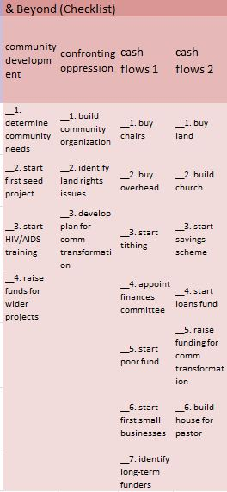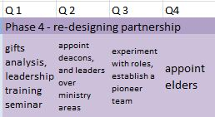

Phase 4: Re-Designing Partnership

Prepare to phase out planting team & raise up and equip leaders from within the new church.

1. Gifts & Leadership:
   1. Assess giftings of church members
   2. Pinpoint & mentor those who might carry on leadership after church planter is finished
2. Appoint Deacons & Leaders
3. Establish Pioneer Team
4. Appoint Elders

& Beyond

Holism: Initiatives Engaging Community

Once the church is secure as a body of believers committed to each other, continue in service opportunities, and begin now to consider a church building for the long term.

1. Community Development
   1. Assess community’s needs & assets, and determine a beneficial outreach project
2. Confronting Oppression
   1. Organize church & community to address relevant issues (ie. land rights)

Cash Flows Paralleling Each Phase

1. Initial Cash Flows (Phase 1 & 2)
   1. Agree on whether money is needed & what it might be used for
   2. Begin tithing
   3. Purchase basics (ie. chairs, Bibles…)
   4. Poor fund (lest we become purchase-oriented)
   5. Identify funders
2. Cash Flows (Phase 3 & 4)
   1. Acquire land; build church
   2. Facilitate savings & loans
   3. Fundraising to support community transformation
   4. House for pastor

Financial Accountability

Funds will be received & managed through office staff at MMP (Mission Ministries Philippines)

Address

Yearly Accounts available

MISSION MINISTRIES

US / Canada partners can make a check out to ***Mission Ministries, Inc***, a registered 501C3, and send to:

c/o John Mark Lindvall  
P.O. Box 10044  
Costa Mesa,  CA 92627

*(a tax-deductible receipt will be sent )*

Tel No. (909)- 6217035

<http://www.mmphilippines.org/>

2 Year Budget:

|  |  |  |  |  |
| --- | --- | --- | --- | --- |
| Item | Description | Annual Rate | Multiplier | Total |
| Salary: Church planters (includes travel expenses) | **Team of 3** per church:  2 planters & 1 pastor to remain | **$837 each** per year  (1/3 of ‘minimum wage,’ Manila) | x 2 years | $5,022 |
| Land: Classroom/Worship | One 100m2 lot  (squatter right of possession) | $3,488 one-time |  | $3,488 |
| Building: Classroom/Worship | One (60 pupils, 20 at a time) | $3,488 one-time |  | $3,488 |
| MMP Admin fee: 10% of church planters’ salaries | For rentals; utilities; salaries of accountant & office manager | $84 each per year | x 2 years | $502 |
| **TOTAL:** |  |  |  | **$12,500** |

Income Projections:

Other sources of income:

Mother Church – $200/year – general expenses $ 400

Church Planters’ Personal Contacts – $2,000/year - salary $ 4,000

New Members of Church Plant – $300 – church building $ 300

TOTAL $ 4,700

**Amount requested: $ 7,800**



What is Holistic Churchplanting

The gospel is good news of the Kingdom of God transforming all levels of life in the city and the slums

* SPIRITUAL
* ECONOMIC
* SOCIAL
* JUSTICE

Evaluation & Accountability

Quarterly newsletters will be sent out to all funders, stating:

* how funds are being utilized
* amount received that quarter (above/below target)
* church growth statistics
* stories of successes and struggles
* prayer points & ways to be involved

With questions on this proposal, contact:

**Katie Gard**

[gard.katie@gmail.com](mailto:gard.katie@gmail.com)

+63-927-240-9355

skype: katie.gard

Katie Gard  
c/o Merly Gamos  
0734 Area 6 Barangay Botocan Project   
Quezon City, Philippines.

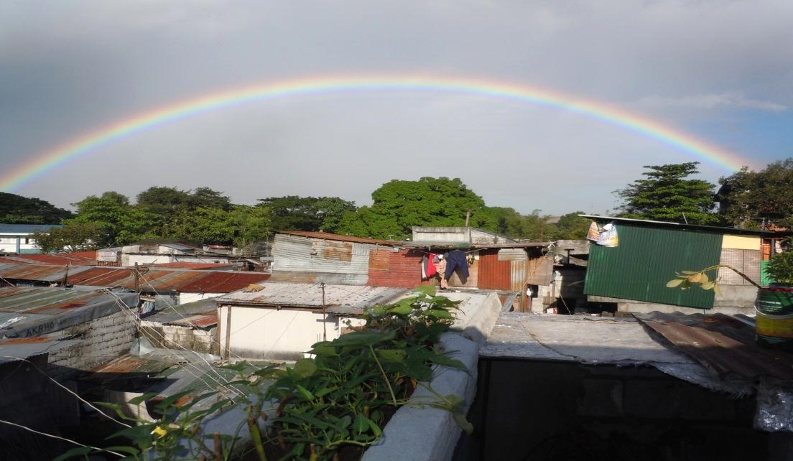

**9 Principles of**

**Evangelistic Momentum**

(Grigg. Cry of the Urban Poor. p133-144.)

* **Compassion**

"Compassion means much love, a little response, and great pain" (134)

* **Intercession**

*"Collective commitment to a simple, sacrificial lifestyle, coupled with a growing experience of the power and gifts of the Holy Spirit" (134).*

* **Find the Man of Peace**
* **Incarnation**
* *"We need to live among the people at their level--not independent of them--despite our resources" (136).*
* **Authority / Status**
* **Proclamation**

*Jesus spoke to people's specific needs with knowledge of their situations and divine wisdom (141).*

* **Exercise of Spiritual Gifts**
* **Small Group Bible Studies**
* **Stand firm in Opposition**

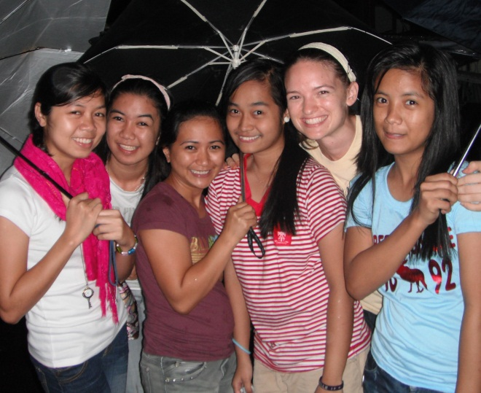

Some References

* Becker, Paul; Jim Carpenter; Mark Williams (2011). **Section Five**: Prayerful Planning.  [The New Dynamic Church planting Handbook](http://www.ocieurope.org/LinkClick.aspx?fileticket=QBToCyUH8k8=&tabid=643&mid=1477) (E-book). 187-266.
* Chu, Dr Atty Raineer. DEVELOPMENT OF A COMPREHENSIVE AND TRANSFORMATIVE TRAINING IN URBAN POOR CHURCH PLANTING: A CASE OF MISSION MINISTRIES PHILIPPINES, INC. (MMP). Seattle. May 2011.
* Coleman, R. E. (1993). *The Master Plan of Evangelism*. Grand Rapids, MI, Revellbooks.
* Eims, LeRoy (2009). The Lost Art of Disciple Making (ch 5). Zondervan. Kindle Edition.
* Grigg, V. (2004). *Companion to the poor*. 2nd edn. Authentic.
* Grigg, V. (2004). *Cry of the Urban Poor.* Authentic.
* Moore, Ralph. (2002). [Buildings, Where should you meet?](http://vizedhtmlcontent.next.ecollege.com/CurrentCourse/Moore10starting%20a%20new%20church.pdf) In *Starting a new church: the church planter’s guide to success* (pp. 115-127). Regal.
* Olson. *Organic Church Planting.*